**Experiment 1.3**

**Student Name: Yash Gupta UID: 20BCS5009**

**Branch: BE-CSE Section/Group:20BCS_DM-716 B**

**Semester: 6 Date of Performance:**

**Subject Name: MAD LAB Subject Code: 20CSP_356**

## Aim:

Create Application by Using Widgets.

## Objective:

To learn about the App widget and how to use them.

Learn to scroll and drag in android studio.

## Code and output:

## Create a new project

## Hello Android Project

## Choose Blank Activity

## Lightbox

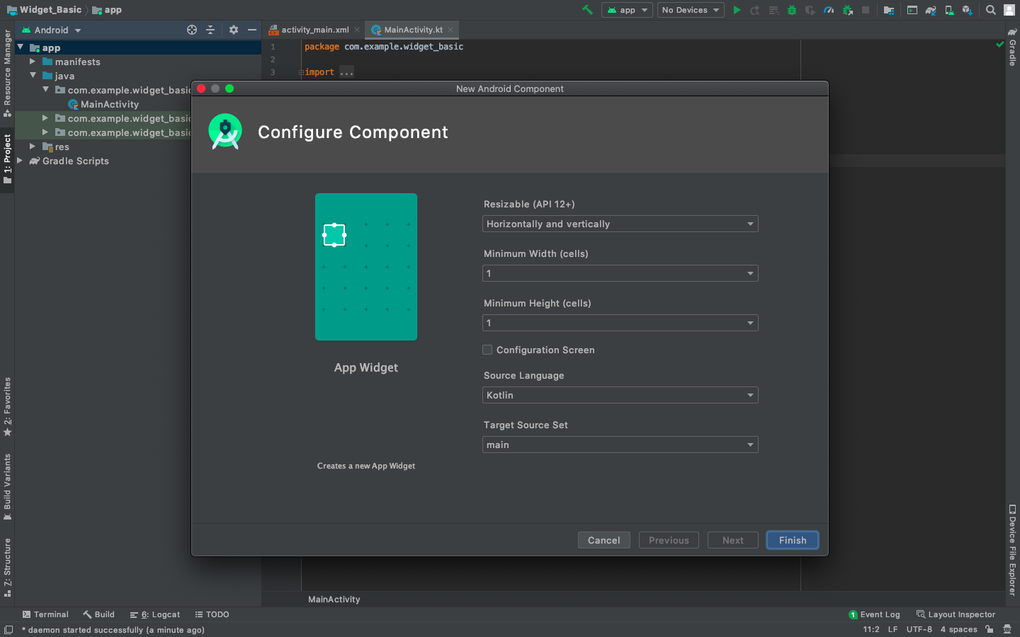

import android.appwidget.AppWidgetManager

import android.appwidget.AppWidgetProvider

import android.content.Context

import android.widget.RemoteViews

class NewAppWidget : AppWidgetProvider() {

    override fun onUpdate(

        context: Context,

        appWidgetManager: AppWidgetManager,

        appWidgetIds: IntArray

    ) {

        // There may be multiple widgets active, so update all of them

        for (appWidgetId in appWidgetIds) {

            updateAppWidget(context, appWidgetManager, appWidgetId)

        }

    }

    override fun onEnabled(context: Context) {

    }

    override fun onDisabled(context: Context) {

    }

}

internal fun updateAppWidget(

    context: Context,

    appWidgetManager: AppWidgetManager,

    appWidgetId: Int

) {

    val widgetText = context.getString(R.string.appwidget_text)

    val views = RemoteViews(context.packageName, R.layout.new_app_widget)

    views.setTextViewText(R.id.appwidget_text, widgetText)

    appWidgetManager.updateAppWidget(appWidgetId, views)

}

* + **New_app_widget.xml**

<RelativeLayout

    xmlns:android="<http://schemas.android.com/apk/res/android>"

    android:layout_width="match_parent"

    android:layout_height="match_parent"

    android:background="#09C"

    android:padding="@dimen/widget_margin">

    <TextView

        android:id="@+id/appwidget_text"

        android:layout_width="wrap_content"

        android:layout_height="wrap_content"

        android:layout_centerHorizontal="true"

        android:layout_centerVertical="true"

        android:layout_margin="8dp"

        android:background="#09C"

        android:contentDescription="@string/appwidget_text"

        android:text="@string/appwidget_text"

        android:textColor="#ffffff"

        android:textSize="24sp"

        android:textStyle="bold|italic" />

</RelativeLayout>

